**InvalidName Exception:**

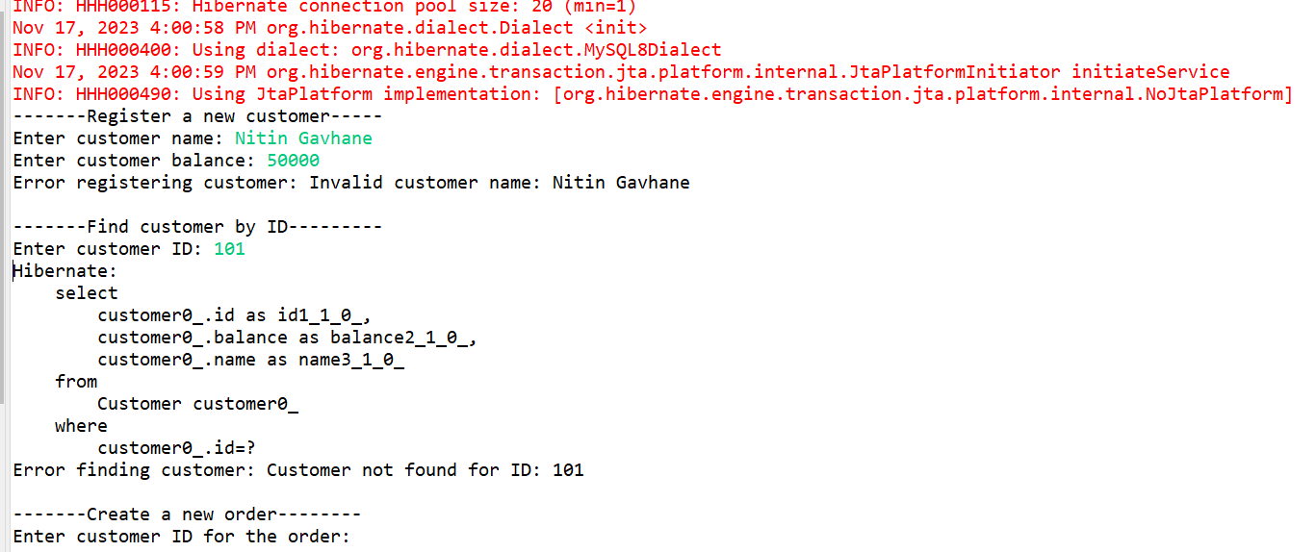

**1)**      **Register customer**

**2) Find customer by id**

**3)**      **Create order**

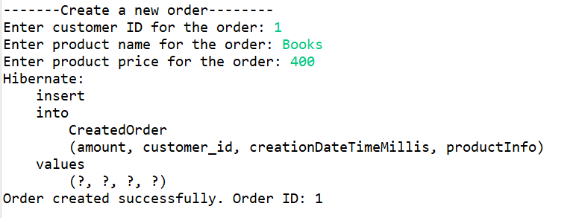

**4)**      **Find Order by id**





**SQL Query:**

**Create database.**

create database jpa;

**use database**

use jpa;

**Create Table Customer**

CREATE TABLE Customer (

id BIGINT PRIMARY KEY AUTO_INCREMENT,

name VARCHAR(15) NOT NULL,

balance DOUBLE NOT NULL

);

**Create Table CreatedOrder**

CREATE TABLE CreatedOrder (

id BIGINT PRIMARY KEY AUTO_INCREMENT,

customer_id BIGINT,

creationDateTimeMillis BIGINT,

amount DOUBLE,

productInfo VARCHAR(255),

FOREIGN KEY (customer_id) REFERENCES Customer(id)

);

**Table Customer**

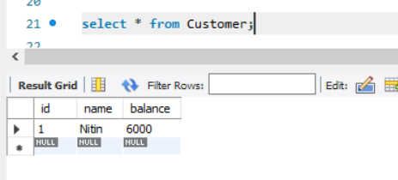

**Table Createorder**

